# Journals

* Estuaries & Coasts <https://www.springer.com/journal/12237/submission-guidelines>
  + The journal covers research on physical, chemical, geological or biological processes, as well as applications to management of estuaries and coasts. Submissions that are primarily descriptive, strongly place-based, or only report on development of models or new methods **without detailing their applications** fall outside the scope of the journal.
* (NAS publishes in this one a lot, hesitancy to target first.
* ~~Ecological Indicators <https://www.sciencedirect.com/journal/ecological-indicators>~~ 
  + ~~aim of~~ *~~Ecological Indicators~~* ~~is to integrate the~~ **~~monitoring~~** ~~and~~ **~~assessment~~** ~~of~~ **~~ecological~~** ~~and~~ **~~environmental indicators~~** ~~with~~ **~~management~~** ~~practices. … Broader assessment objectives and methods, e.g. biodiversity, biological integrity, and sustainability, through the use of indicators. The journal seeks innovative papers which provide new developmental and methodological steps for environmental indication. Submissions of results from simple monitoring programs or single case studies, resulting in descriptive approaches without any exploration from the theory of indication, from the methodology of indication, or from the~~ **~~management points of view~~** ~~are not considered suitable for publication in Ecological Indicators.~~
  + ~~~16 wk submission to publication time (6-8 wks first decision)~~
    - ~~Q1, $2600 USD open access fee~~

Estuary marsh habitat recovery following intensive grazing by an non-native herbivore

# Abstract

Cumulative threats are impacting estuaries globally. Legacies of human alterations to the landscape leave habitat vulnerable to natural disturbance such has overgrazing. In the Pacific Northwest of North America, resident hyper-abundant populations of non-native Canada geese (*Branta canadensis*, “CAGO”) are leading to estuary marsh habitat degradation.  As land and resource managers grapple with how to manage these impacts, our research highlights the trajectory of marsh recovery and reveals that non-native plant species are poised to recolonize degraded marsh ecosystems following CAGO removal. After 10 years of passive recovery, we found abundance of non-native grasses were XX more abundant in the above-ground vegetation, and YY more abundant in the surface seed bank compared to ungrazed sites. [compare to 1 yo or denuded sites?] [Mgmt implications]

# Introduction

Cumulative threats are impacting estuaries globally. Legacies of human alterations to the landscape leave habitat vulnerable to natural disturbance such as grazing. Around the Salish Sea in the Pacific Northwest of North America, hyper-abundant resident populations of non-native Canada geese (*Branta canadensis*) are causing tidal marsh habitat degradation through overgrazing. Marsh vegetation may passively recover through natural recruitment, however plant species compositional abundance during the recovery period may be driven by competitive strategies, resulting in alternative successional trajectories (Muench & Elsey‐Quirk, 2019; Tilman, 2004).

In estuaries, species competitive dominance are environmentally constrained by elevation gradients above sea level, which restricts community composition to species adapted to inundation and salinity conditions at a given elevation (Bertness & Ellison, 1987). Plants may exhibit different competitive advantages through alternative reproductive strategies, such as clonal reproduction or heavy seed production. Tradeoffs exist, however, such as highly competitive clonal reproduction at expense of seed limitation (e.g., *Carex lyngbyei*; CITE). Or, plants may have equally strong clonal and seed reproductive capability, increasing the species’ opportunity for community dominance (e.g., non-native sp.; CITE). Therefore, the recruitment of a species (native or non-native) may be positively or negatively affected by parent plant/seed bank linkages and feedbacks (CITE). Should a species’ competitive strategy (seed or clonal) be removed from the community during a disturbance event, then recovery of that species via succession would be influenced by the relative competitive advantage of remaining propagative material in the disturbed area. Successional trajectories and resulting ecosystem states may vary depending on the composition, and relative rate of recovery of the available propagative sources. If remnant vegetation capable of clonal reproduction remains, then recovery is dependent on the rate at which the vegetation may spread clonally. Alternatively, if recovery is driven by individuals growing from seed, then seed dispersal and retention at the site is required. In wetlands, dissimilarity of seed banks and parent vegetation increases with greater time since disturbance (Hopfensperger, 2007). If both seed and clonal propagative sources are present, then their respective growth rates will determine succession and compositional states, and resulting ecosystem characteristics.

The reproductive strategies of a plant community may thus affect an ecosystem’s resilience, allowing it to return to a compositional state similar to pre-disturbance conditions (Standish et al., 2014). Some ecosystems experience regular natural disturbance, which may be environmental, or from biotic interactions. Natural disturbance may promote ecosystem resilience (CITE), however, if disturbance is persistent or return intervals exceed recovery time, ecosystems shift to alternate compositional or functional states (CITE). Overstress, such as through overgrazing, would lead to reduced capacity for the community to recover through loss of reproductive members (especially clonally reproductive parent vegetation) within plant populations. The Green World Hypothesis (Hairston, Smith, & Slobodkin, 1960) would posit that grazing pressure must be released as predators should take advantage of herbivore populations. However, if grazers are not limited by predation, then grazing pressure can alter site ecology and thus limit the capacity of the habitat to recover (Srivastava & Jefferies, 1996). A key knowledge gap is to understand how recovery proceeds in an ecosystem which regularly experiences natural disturbance, such as estuaries.

Estuaries inherently experience natural disturbance in the form of daily tides, seasonal storms, or over longer geomorphic timescales and processes such as marsh accretion, erosion, or subsidence (Pasternack, 2009). Their immense habitat value to marine species such as salmonids and shorebirds is reflected in national and international efforts for conservation and restoration (CITE). The brackish marshes of estuaries in the PNW are characterized by perennial graminoids (sedges, rushes, and some grasses), which are most often clonally reproductive, with some seed-limited species such as Lyngbye’s sedge (*Carex lyngbyei*) (CITE). Their habitat importance, especially along channel edges, is owed to their tall (up to 1m) vegetation overhanging the channel to provide shade for juvenile salmonids and forage for waterfowl (CITE). Many waterfowl species are seasonal migrants, and these estuaries are important habitat as part of the Pacific Flyway (CITE). Some waterfowl species are resident, which increases the habitat value for year-round occupancy. The Canada goose (“CAGO”) was historically an infrequent migrant to the PNW, but in the later 20th century resident populations were introduced to promote hunting tourism. Their regional population has since exploded, resulting in the development of CAGO management plans to curtail negative impacts such as overgrazing and fecal coliform in municipal spaces (CITE). In estuaries, CAGO grazing behavior is particularly concerning not only because they heavily graze the leafy above-ground vegetation, but they “grub” or rip out the rhizomes that would be capable of clonally growing to restore the vegetation after grazing (CITE). This behavior has led to restoration efforts to physically barricade CAGO from marsh vegetation through the construction of fences, or exclosures. Exclosures are commonly used in a variety of land management applications to prevent herbivory (CITE?), and in PNW estuaries on Vancouver Island, they are an immediate solution to allow the vegetation the opportunity to passively recover (as opposed to active restoration through transplanting new plants). The intended outcome is that by excluding CAGO, the vegetation will passively recover via natural succession to restore estuary habitat to a species compositional abundance characteristic of an ungrazed habitat. Whether this approach leads to intended outcomes has not been tested, and offers an opportunity to understand whether passive restoration measures are sufficient to restore habitat of a desired compositional palette of native species.

The main objective of this study was to understand compositional changes of surface seed banks and above-ground vegetation at discrete stages of recovery since grazing exclusion in two Salish Sea estuaries. We wanted to know if grazing exclusion allows species to passively recover to a compositional abundance similar to undisturbed sites. Traditional succession models would say the most competitive species will increasingly dominate the plant community as time since disturbance increases. This would particularly be the case in a clonal ecosystem, where recovery is driven by species spreading clonally from adjacent undisturbed sites, in addition to potential recruitment from the seed bank. If succession is happening the we expect:

1. Above-ground vegetation at older disturbance sites will be more similar to reference vegetation than recently disturbed (regardless of seed inputs), with respect to compositional abundance of tall, perennial graminoids (TPGs) which dominate this ecosystem.
   1. Alternatively, novel disturbance and novel seed inputs lead to alternative succession pathways, where new competitors from seed inputs derail the "slow encroachment" of the clonal dominant from the neighboring intact site.
2. Above-ground vegetation in recently disturbed sites will be highly similar to seed inputs than older disturbance vegetation similarity to seed, or reference vegetation similarity to seed, especially with respect to compositional abundance of TPGs.

From a conservation and land management perspective, we should be cognizant of long-term grazing impacts on recovery of plant communities and the implications for alternate successional trajectories. This is especially the case in ecosystems that already experience natural and anthropogenic disturbance, such as estuaries, and wetlands more broadly.

# Methods

## Study area & site history

The Little Qualicum River Estuary (LQRE) and Nanaimo River Estuary (NRE) are situated on the east coast of Vancouver Island along the Strait of Georgia (Figure 1). Both have a history of colonial impacts such as agriculture, and industrial impacts in the NRE. The LQRE was designated as a Wildlife Management Area (WMA) in YYYY, while NRE has been designated as a Wildlife Refuge. Because these designations confer protection of wildlife habitat, they have been heavily utilized by resident and migratory waterfowl including CAGO (CITE). Observation of intensive grazing in the LQRE led to the establishment of exclosures in 2010 as a trial method to prevent herbivory (DAWE?). Local conservation group Guardians of Our Salish Estuaries (formerly Guardians of Mid-Island Estuary Society) continued exclosure construction in both estuaries, opportunistically protecting channel edges where herbivory was most intensive to prevent further loss of habitat (FIG). Exclosures included in this study were selected to represent comparable disturbance conditions at the time of exclosure construction. Despite efforts to protect marsh and channel edge habitat, herbivory is ongoing and areas of habitat degraded by excessive grazing/grubbing remain; grubbed sites selected for comparison were not protected by an exclosure during the study period. Within each estuary, ungrazed habitat is typically found further upstream along tidal channels or interior to the channel edge, and were not protected by exclosures during the study period.

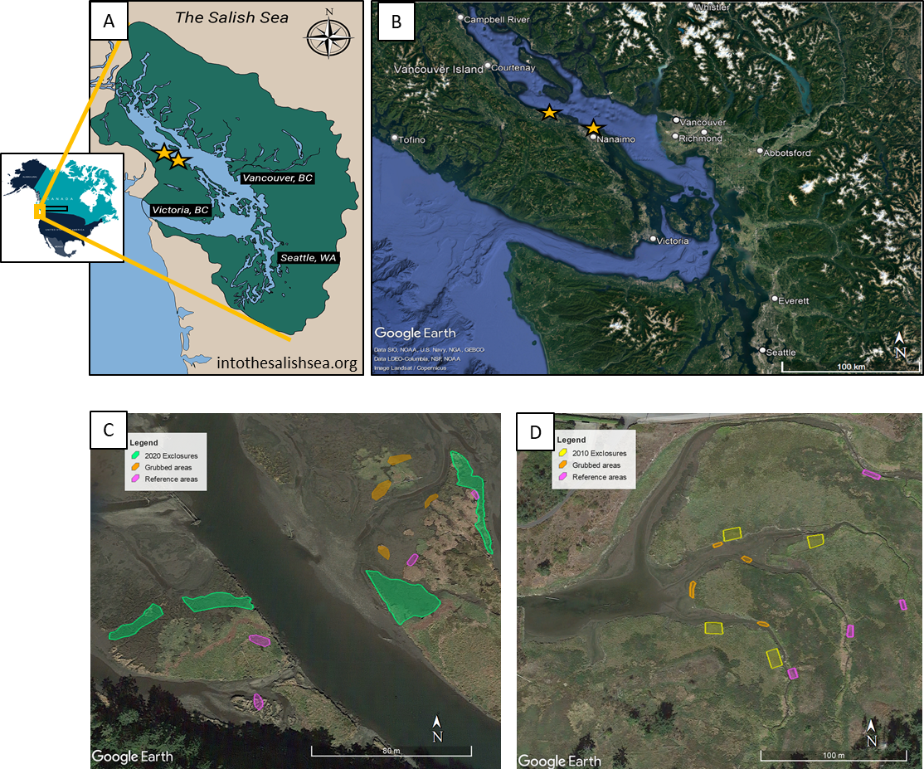

Figure 1. The Salish Sea spans the US-Canadian border on the Pacific Coast of North America (A). Two estuaries located on the southeastern coast of Vancouver Island (B) were surveyed where grazing disturbance and recovery were observed in the Nanaimo River Estuary (C) and Little Qualicum River Estuary (D).

Table 1. Grazing disturbance conditions in the Little Qualicum River and Nanaimo Estuaries resulted in conversion of vegetated marsh to partially or fully grubbed mudflats; exclosures were installed to prevent further degradation into the marsh platform. Each estuary sampled n = 4 sites for disturbance category. Two 1 m2 plots were sampled within each site, and two surface seed banks samples were taken from each plot.

|  |  |  |  |  |  |  |  |
| --- | --- | --- | --- | --- | --- | --- | --- |
| **Estuary** | **Time Since Disturbance** | **Disturbance condition** | **Revegetation status** | **Protected by exclosure?** | **Number of sites (exclosures, or comparably sized area)** | **Number of sampling plots per site** | **Number of surface seed bank samples per plot** |
| Little Qualicum, Nanaimo | 0 years (recent grubbing disturbance) | Grubbed | No manipulations | No | 8 | 2 | 2 |
| Nanaimo | 1-year post-grazing/grubbing disturbance | Partially grubbed | No transplants; vegetation recovery from remnant and adjacent vegetation | Yes | 4 | 2 | 2 |
| Little Qualicum | 10 years post-grazing/grubbing disturbance | Partially grubbed | No transplants; vegetation recovery from remnant and adjacent vegetation | Yes | 4 | 2 | 2 |
| Little Qualicum, Nanaimo | No known grazing disturbance | Undisturbed | No manipulations | No | 8 | 2 | 2 |

## Sampling methods

### Vegetation sampling

Vegetation sampling was conducted once in mid-July, 2021. Two 1 m2 vegetation plots were placed within the exclosures (sites, n = 4 per estuary), at least 1 m from the bank edge and any exclosure boundary, and at least 3 m apart within the exclosure. Quadrats were placed so that the plot edge nearest creek was parallel to the bank.

All vascular species were identified according Hitchcock and Cronquist (1973), and currently accepted nomenclature standardized according to the PLANTS Database of the United States Department of Agriculture, Natural Resources Conservation Science [USDA NRCS]. Species were considered in the plot if at least half of their basal stem(s) were inside the quadrat boundary; overhanging vegetation originating from basal stems outside the plot was not considered. Aerial vegetated cover was estimated to the nearest 3 % (1/32 m2). For any species present with less than 3 % cover, species were assigned 2% cover if > 20 individuals were present, 1 % cover if 2-20 individuals were present, and 0.1% cover for single individuals. Bare ground was estimated as the remainder of the plot area not covered by above-ground vegetation. Any plots with > 100% cover were standardized relative to 100%. To characterize plant structure, species were assigned to a height category tall (> 1 m), medium (50-100 cm), or short (< 50 cm) based on their maximum reported height in the Illustrated Flora of British Columbia (Douglas, Meidinger, & Pojar, 1998).

### Surface seed bank sampling & germination

Two surface seed bank samples were taken from each plot (n = 16 per disturbance condition in each estuary) in summer (July 2020), fall (October 2020), and spring (March 2021). A 10 cm diameter handheld bulb planter (e.g., [Husky 9 in. stainless Steel Bulb Planter, Home Depot, USA](https://www.homedepot.com/p/Husky-9-in-Stainless-Steel-Bulb-Planter-GD210314/317436441)) was used to excise sediment 1 cm deep to capture the surface seed bank. Vegetative roots, rhizomes, or other viable rooted material were removed before placing sample in a plastic zipper bag. All surface seed bank samples from the same estuary and disturbance condition were then homogenized in a clean bucket with 100 mL dechlorinated water. Samples were hand-sifted for any remaining root, rhizome, or vegetative material, then homogenized sample was transferred to a clean plastic zipper bag. Summer and fall 2020 samples were stored at 4o C for approx. 12 weeks to simulate overwinter cold stratification to release seed dormancy (CITE); samples collected in the spring of 2021 underwent natural winter conditions and were not subjected to cold stratification.

Germination trials were conducted under greenhouse conditions with 15 hr daylength at ~ 20o C. Seedling pots (9 cm x 13 cm x 5.7 cm (depth), BRAND) were filled with moist, sterile potting media (Sunshine Mix No. 4, Sun Gro Horticulture, Agawam, MA, United States). Pots were placed in solid cache trays and constantly bottom-watered with municipal tap water.

Seed bank samples were sown by pouring 75 mL sediment over the top of each seedling pot (n = 8 per estuary and disturbance condition) while constantly agitating the homogenized seed bank sample. Seeds were allowed to germinate for 5 weeks, at which time all individuals were counted and removed. The seedling trays were observed for any further germination for another 7-10 days, at which time the samples were discarded. Any species that could not be identified were labelled and transplanted into 38 P plug trays (BRAND) with the same growing media and growing conditions until a positive identification could be made. Representative specimens used to confirm seedling identification were pressed and made available as herbaria.

## Analysis

Tall, perennial graminoids (TPGs) were the response variable of interest because they are the dominant species group in high marsh estuarine communities.

We used generalized linear models with a binomial distribution to fit the response of TPG compositional abundance to test whether species compositional abundance differed among disturbance recovery categories in the above-ground and surface seed bank, respectively (package).

We used indicator species analysis (“indicspecies,” R package De Caceres & Jansen, 2016) to determine which species were significantly characterizing the above-ground vegetation and surface seed bank in each disturbance condition. Species significantly driving compositional abundance in each disturbance category were defined by a biserial correlation coefficient (multipatt func = “r.g.”) and permutational analysis (Dufrene & Legendre, 1997).

# Results

We found above-ground cover abundance of tall, perennial graminoids (TPGs) in 10-year old exclosures recovered to comparable cover abundance as found in Undisturbed sites, supporting our first hypothesis (Figure 2). Unsurprisingly, generalized linear models showed Grubbed sites had significantly lower TPG above-ground cover than Undisturbed sites (p = 0.02), and 1-year old exclosures had nearly significant less TPG cover than Undisturbed sites (p = 0.09).

However, despite the group of tall, perennial graminoids dominant vegetation : ia single, *Agrostis stolonifera* (Table 2). This non-native species also characterized the surface seed banks of both the 10-year old exclosures and Undisturbed sites, lending support for our alternative hypothesis that new competitors from the seed bank and/or competitive advantage of a species’ clonal reproduction strategy would replace species which dominate in the absence of disturbance, such as *Carex lyngbyei*.

We found the surface seed bank composition of TPGs varied by estuary and disturbance (Figure 2). Our generalized linear models showed Nanaimo River Estuary had significantly lower TPG seed abundance overall (p = 0.02), and Grubbed sites have significantly lower TPG seed abundance, regardless of estuary (p = 0.05). The indicator species for surface seed banks in 10-year old exclosures alone were very similar to the vegetation in Undisturbed sites, while surface seed banks in Undisturbed sites showed some similarity to the above-ground vegetation in Undisturbed sites. Undisturbed sites had the same sedge species, and two native rushes: *Juncus articulatus* in the surface seed bank, and *J. balticus* in above-ground vegetation, in addition to two different forb species. (Table 2)

It is especially apparent that abundances of species present in the surface seed bank are not always proportional to the abundance of the same species in the above ground vegetation (Table 2, Figure 3). Grubbed sites and 1-year old exclosures had more indicator species in above-ground vegetation, while their surface seed banks were dominated by two species (neither of which were TPGs): *Eleocharis parvula*, and *Spergularia canadensis*. Undisturbed sites and 10-year old exclosures had a greater richness in the surface seed bank (Table 2), with some species of greater abundance similar to the Grubbed and 1-year old exclosures (Figure 3). Some TPG seeds had high abundance in the surface seed bank, such as native rush *Juncus balticus*, and non-native grass species *A. stolonifera*. Notably, abundance of native keystone sedge *Carex lyngbyei* was greatest in Undisturbed sites in Little Qualicum Estuary, although this accounted for less than 20% of all seed relative abundance. However, *J. balticus* was twice as abundant, and *A. stolonifera* approx. five times as abundant in the surface seed bank.

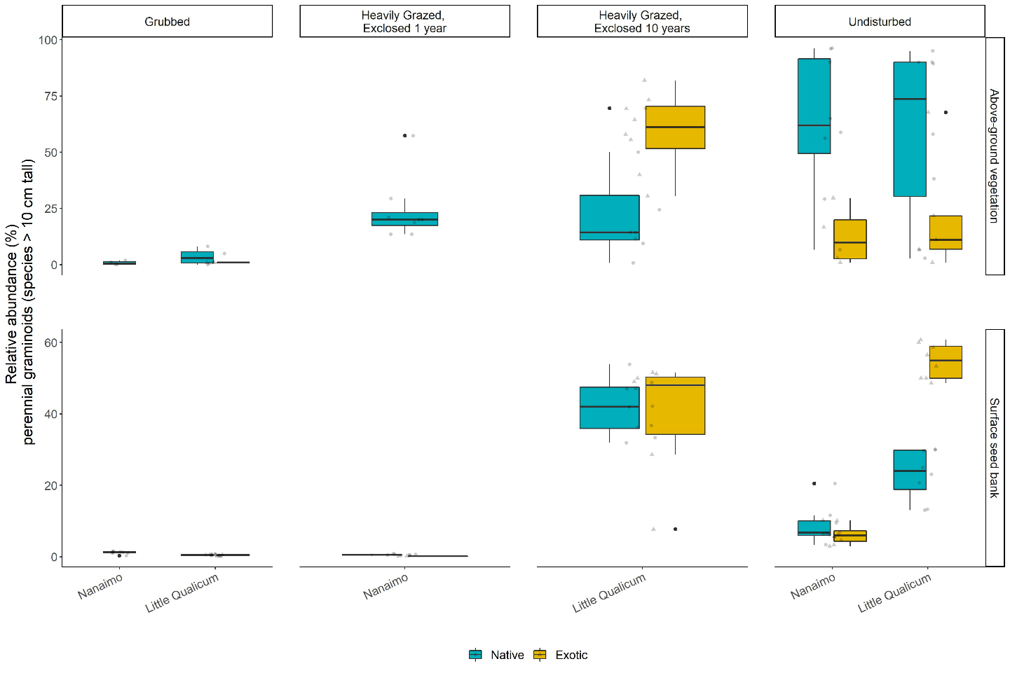

Figure 2. Above-ground cover abundance of key functional group ‘perennial graminoids (> 10 cm)’ is not significantly different from undisturbed (reference) sites after 10 years. However, indicator species analysis reveals this above-ground cover is dominated by non-native graminoid species Agrostis stolonifera. Moreover, seed bank abundance of tall, perennial graminoids is significantly higher in 10-year old exclosures compared to other disturbance conditions, including undisturbed (reference) sites. Notably, there is nearly equal abundance of non-native and native graminoid seed in 10-year old exclosures, and significantly greater representation of non-native than native graminoid seed in undisturbed sites in Little Qualicum Estuary.

Table 2. Indicator species analysis identifies which species significantly characterize the above-ground vegetation (left panel) and surface seed bank (right panel) for each disturbance condition, or combination of “recently disturbed” (1-year old exclosures and Grubbed sites) and “recovered” (10-year old exclosures and Undisturbed sites) disturbance conditions. Non-native species are indicated by (*).



|  |  |  |  |  |  |  |
| --- | --- | --- | --- | --- | --- | --- |
| Above Ground Vegetation | | |  | Surface Seed Bank | | |
| **Disturbance** | **Species** | **p-value** |  | **Disturbance** | **Species** | **p-value** |
| Grubbed | *Eleocharis parvula* | < 0.01 |  | Grubbed | *Salicornia depressa* | 0.01 |
| *Cotula coronopifolia\** | 0.04 |  |
| 10-year old exclosures | *Agrostis stolonifera\** | < 0.01 |  | 10-year old exclosures | *Juncus balticus* | < 0.01 |
|  | *Triglochin maritima* | 0.05 |
| Reference | *Juncus balticus* | 0.02 |  | Reference | *Carex lyngbyei* | 0.02 |
| *Carex lyngbyei* | 0.02 |  | *Cotula coronopifolia\** | 0.03 |
| *Triglochin maritima* | 0.04 |  | *Juncus articulatus* | 0.04 |
| 1-year old exclosures + Grubbed | *Spergularia canadensis* | < 0.01 |  | 1-year old exclosures + Grubbed | *Eleocharis parvula* | 0.02 |
| *Glaux maritima* | 0.03 |  | *Spergularia canadensis* | 0.03 |
| 10-year old exclosures + Undisturbed | *Potentilla pacifica* | < 0.01 |  | 10-year old exclosures + Undisturbed | *Agrostis stolonifera\** | < 0.01 |

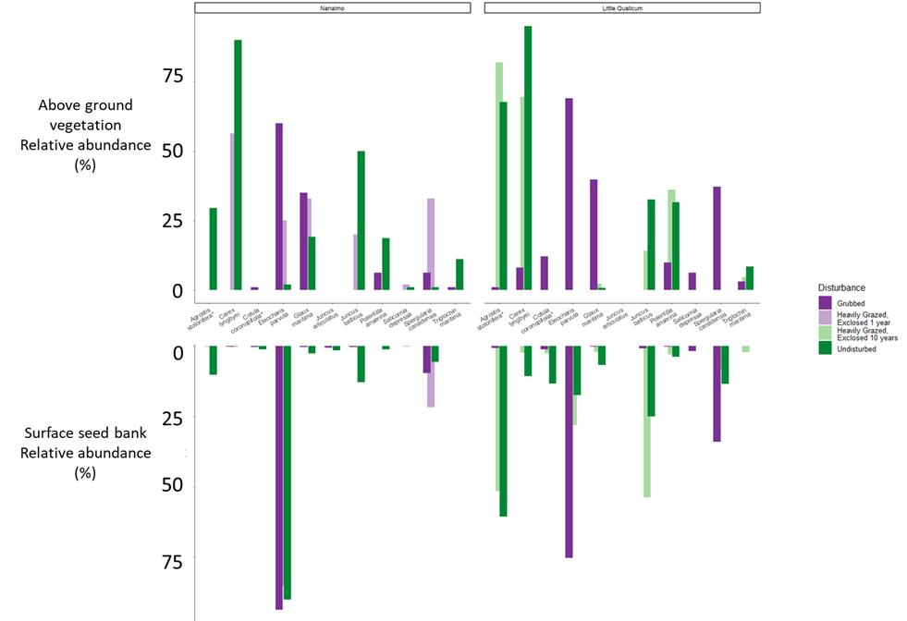

Figure 3. Relative abundance of species identified by indicator species analysis in above-ground vegetation and surface seed bank at each estuary sampled. Notably, abundance of key native TPGs such as Carex lyngbyei are absent from the seed bank, while others such as Juncus balticus are present in the seed bank but absent in above-ground vegetation, such as observed in 10-year old exclosures at Little Qualicum Estuary.

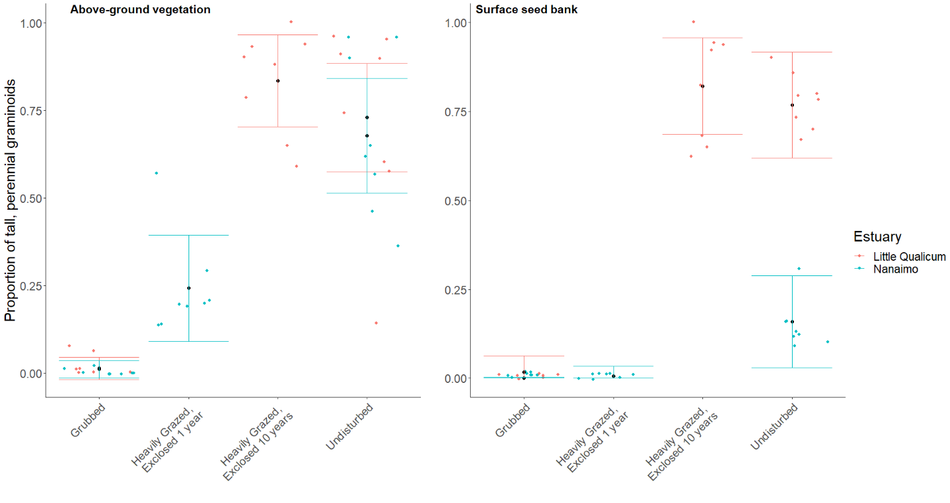

Figure 4. Actual vs. predicted values for proportion of tall, perennial graminoid in above-ground vegetation cover (left) and surface seed bank samples (right) based on disturbance condition. Actual values plotted as colored points; mean values black points with standard error color coded for each estuary.

# Discussion

We sought to understand whether dominant ‘tall, perennial graminoids’ (TPGs) recovers following disturbance, and whether surface seed bank composition reflects above-ground vegetation composition. It is evident that extensive grazing and grubbing behavior of Canada geese remove TPGs from the habitat, to the point of converting habitat dominated by rhizomatous TPGs to mudflat characterized by ruderal forbs and short graminoids (Table 2). While it may seem unnecessary to state this change in composition following herbivory, it is important to emphasize that this affects the habitat’s regenerative capacity by removing clonally-reproductive rhizomes and leads to a dearth of native graminoid species in the surface seed bank.

We found that TPG functional group recovered according to our expectations, but with different compositional abundances. Notably, non-native species *Agrostis stolonifera* dominates above-ground vegetation 10 years following grazing exclusion. We found high species richness in grubbed sites and 1-year old exclosures, but low abundance of seed similar to above-ground vegetation except for two species in these disturbance categories (Sp X, Sp Y). This may indicate a loss of propagules in the surface seed bank, either by erosion or inability of the extant vegetation to trap seeds from nearby parent plants or seeds transported by tidal inundation. Our expectations for high similarity between surface seed banks and above-ground vegetation were partially met, however we did not find a strong pattern of dissimilarity increasing with greater time since disturbance.

Whether vegetation is recovering predominantly by vegetative clonal growth, seed recruitment, or a combination of these mechanisms was not tested. Regardless, it appears non-native species are out-competing natives despite some native species’ presence in the surface seed bank and remnant vegetation in the 1-year old exclosures. We found low abundance of seed for some TPG in Undisturbed and 10-year old exclosures, notably a dearth of seed from *C. lyngbyei*. This suggests that if vegetation is disturbed, seeds are not a likely source of propagative material for most species extant in the above-ground vegetation of Undisturbed sites. The two TPG species with greatest abundance in surface seed banks in Undisturbed sites at both estuaries and 10-year old exclosures in Little Qualicum Estuary were native *J. balticus* and non-native *A. stolonifera*. If these two species had comparable competitive traits, we might expect a similar proportion of cover abundance in the above ground vegetation in 10-year old exclosures. This was not the case, suggesting that non-native species *A. stolonifera* has a competitive recruitment advantage during the recovery period. Competitive advantage of *A. stolonifera* may especially be contributing to lack of recovery of seed-limited native TPGs, such as *C. lyngbyei*.

Overall, relative abundance of most native indicator species was lower in the surface seed bank than the relative abundance of their above-ground vegetation counterparts. Over time and sustained disturbance, this may lead to ‘ecological memory loss’ of native species diversity and compositional abundance as above-ground vegetation is lost to grazing, and subsequently unable to contribute to the surface seed bank. Moreover, as native species’ reproductive mechanisms are lost from the habitat, there is a greater risk of non-native species replacing native species in estuaries. Seed-limited species that rely on clonal reproduction may be at greatest risk for being out-competed if the competitor(s) have greater seed and clonal reproductive rates. We believe we have provided evidence for these processes occurring in the Little Qualicum River Estuary, and this could imply risk of non-native species invasion in younger restoration sites such as those in Nanaimo River Estuary.

Broadly, we may synthesize these findings to recommend areas of attention for habitat managers. Most importantly, the data we present here show that while habitat recovers in terms of plant functional groups, it does not recover the same species compositional abundance in above-ground vegetation or surface seed banks. Thus, passive recovery may be insufficient for native species with a primarily clonal reproductive strategy, especially when non-native species with competitive reproductive advantage of both seed and clonal strategies are present. Whether the non-native species provide the same ecosystem functions such as leaf litter quality for primary productivity, sediment trapping, wave attenuation, etc., remains to be tested (e.g., Waller et al., 2020). Without knowing effects of these changes on habitat quality, best recommendations would be to prevent extensive grazing and grubbing. Our conclusions must be couched within the limitations of two periods of recovery (1 year, 10 years), each in different estuaries, as well as only one year of seed/vegetation data collection. A major challenge to understanding restoration outcomes is replication of restoration conditions, which should be addressed in restoration design and habitat management. Despite these data limitations, we found evidence suggesting surface seed banks are not a reliable source of abundant native seed species to out-compete non-native species. Propagule dispersal and recruitment limitations cannot rescue native populations if local seed or clonal competitive pressure from non-native species is greater. That is, this trend of both native species loss *and* increasing non-native cover is exacerbated by each species’ competitive dispersal and recruitment strategies. Our best recommendations would be to place a high priority on actively restoring desired tidal marsh species through transplanting, and protecting remnant habitat and new transplants with exclosures to prevent further overgrazing. In instances where disturbance has resulted in extensive estuarine habitat loss, there exists the opportunity to intentionally restore diverse native species palettes, which can remedy trends of biodiversity loss (Lane *et al.*, in preparation). Moreover, this offers a chance to enact reconciliation partnerships with local First Nations to use culturally important species, and potentially restore traditional land management practices (e.g., Turner, 2014).

# Literature Cited

Bertness, M. D., & Ellison, A. M. (1987). Determinants of Pattern in a New England Salt Marsh Plant Community. *Ecological Monographs*, *57*, 129–147.

Douglas, G. W., Meidinger, D., & Pojar, J. (Eds.). (1998). *Illustrated flora of British Columbia. Vols. 1-8*. Victoria, BC: B.C. Min. Environ., Lands and Parks, and B.C. Min. For.

Hairston, N. G., Smith, F. E., & Slobodkin, L. B. (1960). Community Structure, Population Control, and Competition. *The American Naturalist*, *94*, 421–425.

Hitchcock, C. L., & Cronquist, A. (1973). *Flora of the Pacific Northwest, an illustrated manual*. Seattle and London: University of Washington Press.

Hopfensperger, K. N. (2007). A review of similarity between seed bank and standing vegetation across ecosystems. *Oikos*, *116*, 1438–1448.

Muench, A., & Elsey‐Quirk, T. (2019). Competitive reversal between plant species is driven by species-specific tolerance to flooding stress and nutrient acquisition during early marsh succession. *Journal of Applied Ecology*, *56*, 2236–2247.

Odum, E. P. (1969). The Strategy of Ecosystem Development. *Science*, *164*, 262–270.

Pasternack, G. B. (2009). Chapter 3. Hydrogeomorphology and sedimentation in tidal freshwater wetlands. In A. Barendregt, D. F. Whigham, & A. H. Baldwin (Eds.), *Tidal Freshwater Wetlands* (pp. 31–40). Leiden, The Netherlands: Backhuys Publishers.

Srivastava, D. S., & Jefferies, R. L. (1996). A Positive Feedback: Herbivory, Plant Growth, Salinity, and the Desertification of an Arctic Salt-Marsh. *Journal of Ecology*, *84*, 31–42. JSTOR.

Standish, R. J., Hobbs, R. J., Mayfield, M. M., Bestelmeyer, B. T., Suding, K. N., Battaglia, L. L., … Thomas, P. A. (2014). Resilience in ecology: Abstraction, distraction, or where the action is? *Biological Conservation*, *177*, 43–51.

Tilman, D. (2004). Niche tradeoffs, neutrality, and community structure: A stochastic theory of resource competition, invasion, and community assembly. *Proceedings of the National Academy of Sciences*, *101*, 10854–10861.

Waller, L. P., Allen, W. J., Barratt, B. I. P., Condron, L. M., França, F. M., Hunt, J. E., … Dickie, I. A. (2020). Biotic interactions drive ecosystem responses to non-native plant invaders. *Science*, *368*, 967–972.

# Supplemental

Table 3. Frequency (%) of species found in above-ground vegetation plot replicates for Nanaimo and Little Qualicum River Estuaries, combined, ranked by greatest frequency found in undisturbed plots.

|  |  |  |  |  |
| --- | --- | --- | --- | --- |
| **Species** | **Grubbed** | **Exclosed 1 Year** | **Exclosed 10 years** | **Undisturbed** |
| *Carex lyngbyei* | 31.3 | 100 | 100 | 100 |
| *Potentilla pacifica-anserina* | 31.3 | 0 | 87.5 | 87.5 |
| *Agrostis stolonifera* | 18.8 | 0 | 100 | 56.3 |
| *Glaux maritima* | 75 | 100 | 75 | 56.3 |
| *Juncus balticus* | 0 | 12.5 | 62.5 | 56.3 |
| *Triglochin maritima* | 50 | 12.5 | 37.5 | 43.8 |
| *Deschampsia caespitosa* | 12.5 | 37.5 | 0 | 25 |
| *Atriplex patula* | 0 | 0 | 0 | 18.8 |
| *Eleocharis parvula* | 100 | 75 | 0 | 12.5 |
| *Symphyotrichum subspicatum* | 0 | 0 | 0 | 12.5 |
| *Agropyron repens* | 0 | 0 | 0 | 6.25 |
| *Distichlis spicata* | 12.5 | 25 | 0 | 6.25 |
| *Salicornia depressa* | 62.5 | 25 | 0 | 6.25 |
| *Spergularia canadensis* | 100 | 100 | 0 | 6.25 |
| *Trifolium wormskioldii* | 0 | 0 | 0 | 6.25 |
| *Cotula coronopifolia* | 68.8 | 12.5 | 0 | 0 |

Table 4. Frequency (%) of species found in seed germination replicates for Nanaimo and Little Qualicum River Estuaries, combined, ranked by greatest frequency found in undisturbed samples.

|  |  |  |  |  |
| --- | --- | --- | --- | --- |
| **Species** | **Grubbed** | **Exclosed 1 Year** | **Exclosed 10 years** | **Undisturbed** |
| *Agrostis stolonifera* | 37.5 | 12.5 | 100 | 100 |
| *Juncus balticus* | 62.5 | 75 | 100 | 100 |
| *Spergularia canadensis* | 100 | 100 | 87.5 | 100 |
| *Eleocharis parvula* | 100 | 100 | 50 | 56.3 |
| *Cotula coronopifolia* | 56.3 | 12.5 | 37.5 | 50 |
| *Carex lyngbyei* | 6.25 | 25 | 25 | 43.8 |
| *Juncus tenuis* | 50 | 87.5 | 0 | 37.5 |
| *Potentilla pacifica-anserina* | 6.3 | 0 | 25 | 31.3 |
| *Glaux maritima* | 43.8 | 12.5 | 37.5 | 25 |
| *Juncus articulatus* | 0 | 0 | 0 | 25 |
| *Symphyotrichum subspicatum* | 6.3 | 0 | 0 | 18.8 |
| *Juncus ensifolius* | 0 | 0 | 0 | 12.5 |
| *Achillea millefolium* | 0 | 0 | 0 | 6.3 |
| *Epilobium ciliatum* | 6.3 | 0 | 0 | 6.3 |
| *Epilobium glaberrimum* | 0 | 0 | 0 | 6.3 |
| *Grindelia sp.* | 0 | 0 | 0 | 6.3 |
| *Isolepis cernua* | 18.8 | 0 | 0 | 6.3 |
| *Triglochin maritima* | 0 | 0 | 25 | 0 |
| *Deschampsia cespitosa* | 0 | 12.5 | 0 | 0 |
| *Distichlis spicata* | 0 | 0 | 0 | 0 |
| *Poa palustris* | 6.3 | 0 | 0 | 0 |
| *Salicornia depressa* | 43.8 | 37.5 | 0 | 0 |

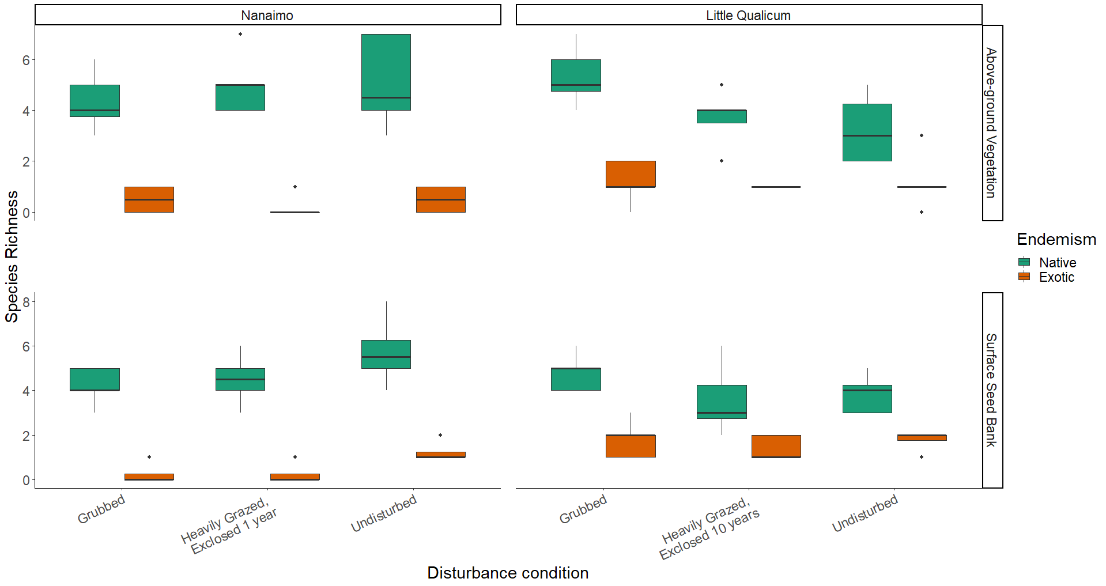

Figure 5. Native species richness is consistently greater than non-native species richness in both above-ground vegetation and surface seed banks for both estuaries and across all disturbance categories.

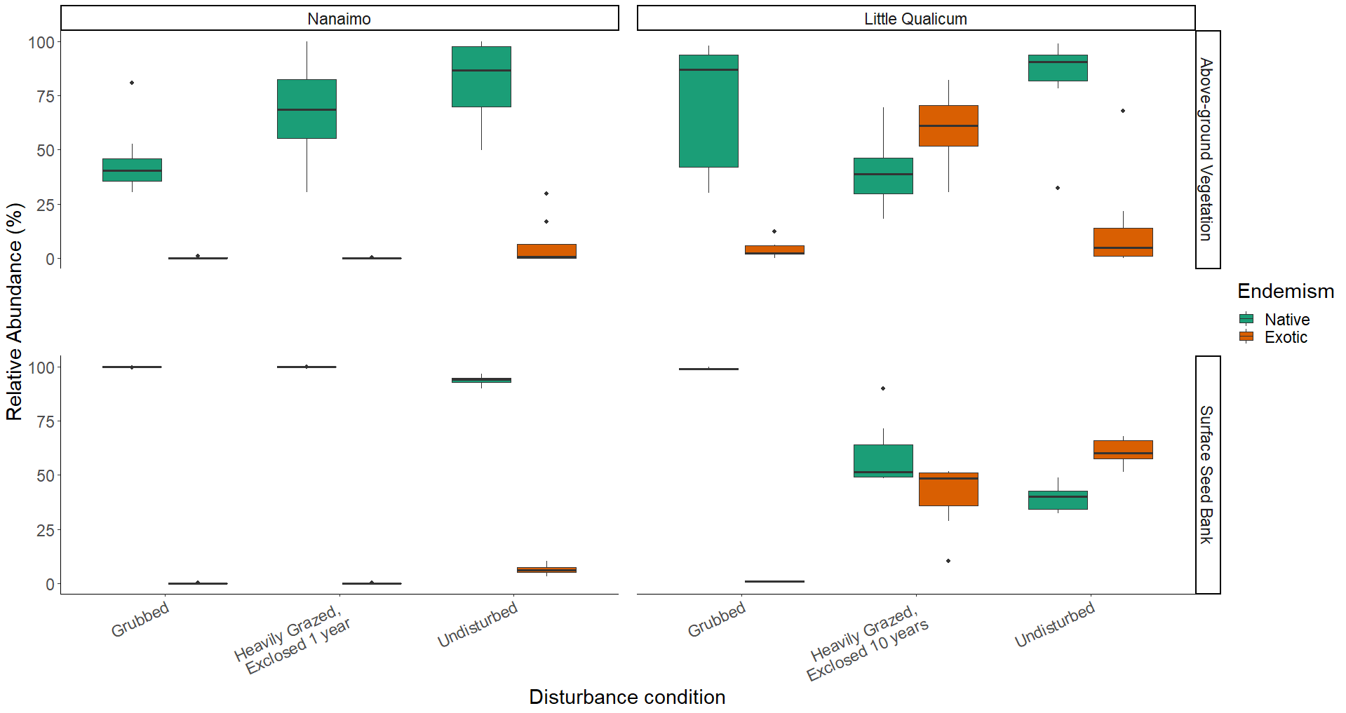

Figure 6. Above-ground cover abundance of all native species is always significantly greater than all non-native species cover, except in 10-year old exclosures in Little Qualicum River Estuary. Notably, non-native species abundance in the surface seed bank is low across all disturbance conditions in Nanaimo Estuary, but equal to or greater than native species in 10-year old exclosures or undisturbed sites, respectively, in Little Qualicum River Estuary.

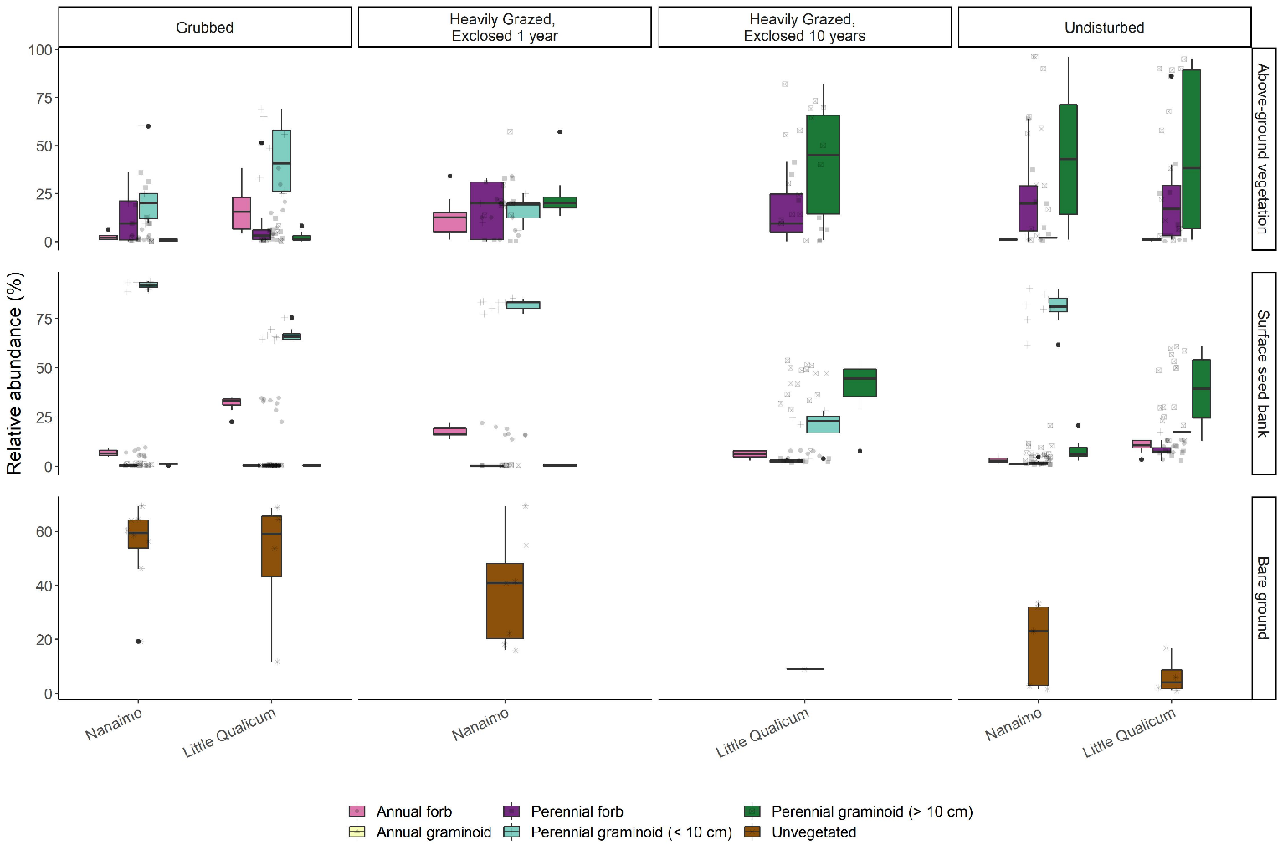

Figure 7. Recently grubbed and 1-year-old exclosures are dominated by > 50% mean cover of bare ground, with species relative abundance dominated by short perennial graminoid Eleocharis parvula and forbs in both above-ground vegetation and surface seed bank. After 1 year of exclosure, all plant functional groups have similar dominance in above ground vegetation, but surface seed banks do not show increased representation from perennial forbs or perennial graminoids > 10 cm. Bare ground significantly decreases after 10 years of exclosure, while relative abundance of perennial graminoids (> 10 cm) significantly increases in both above-ground vegetation and surface seed banks, not significantly different from undisturbed sites.

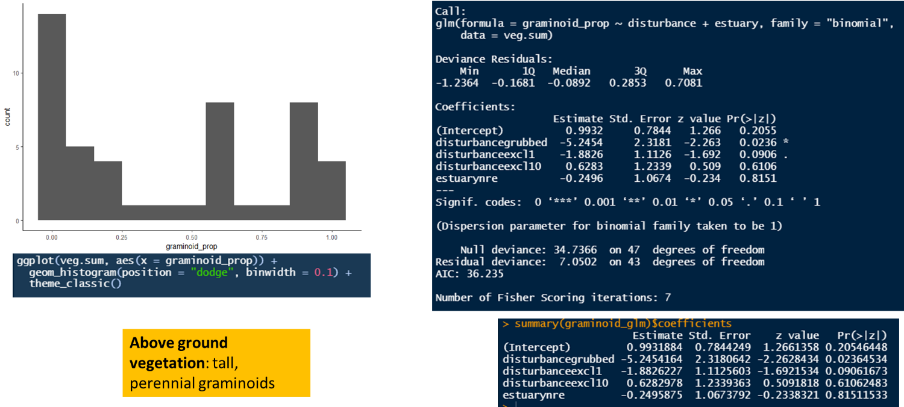

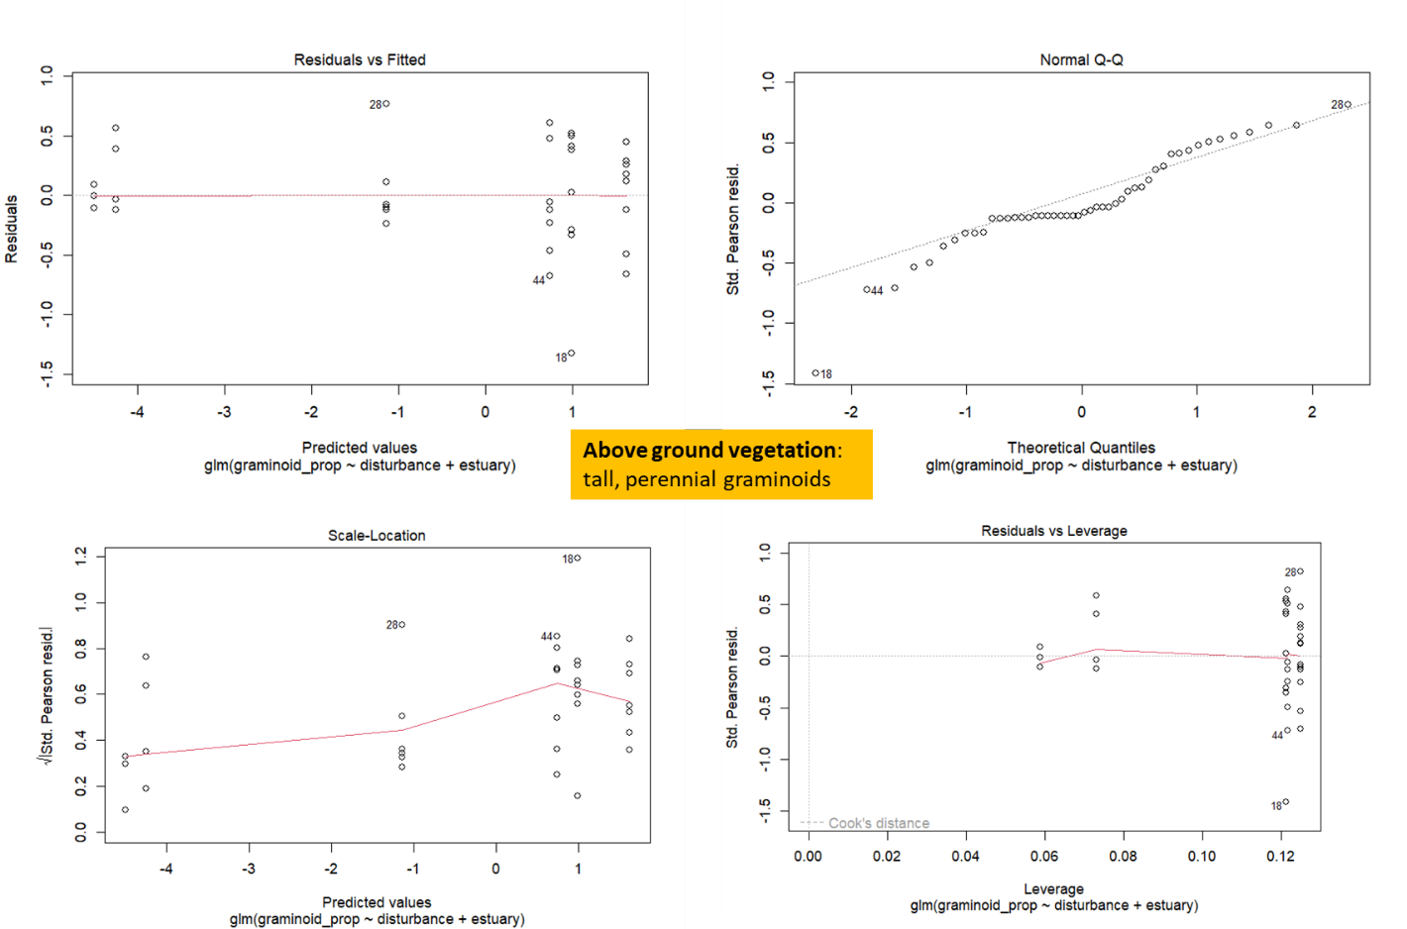

Figure 8. TEMP FIG - code output for in-text Results reporting glm trends in ABOVE-GROUND VEGETATION. Outliers are individual plots heavily dominated by perennial forbs (especially Douglas aster).

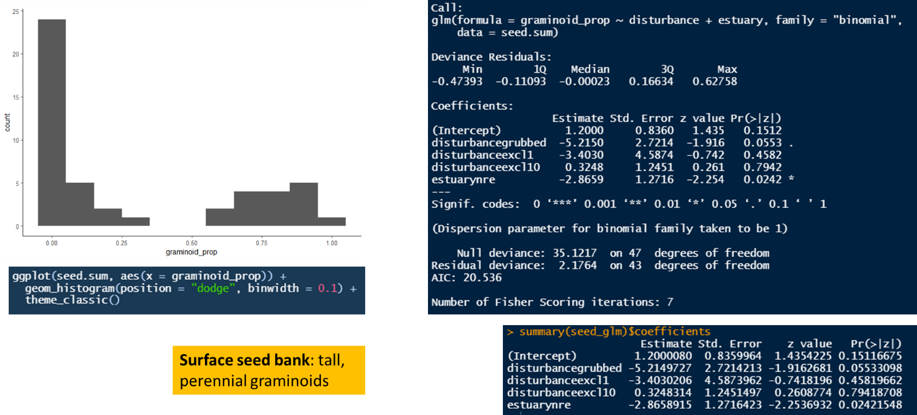

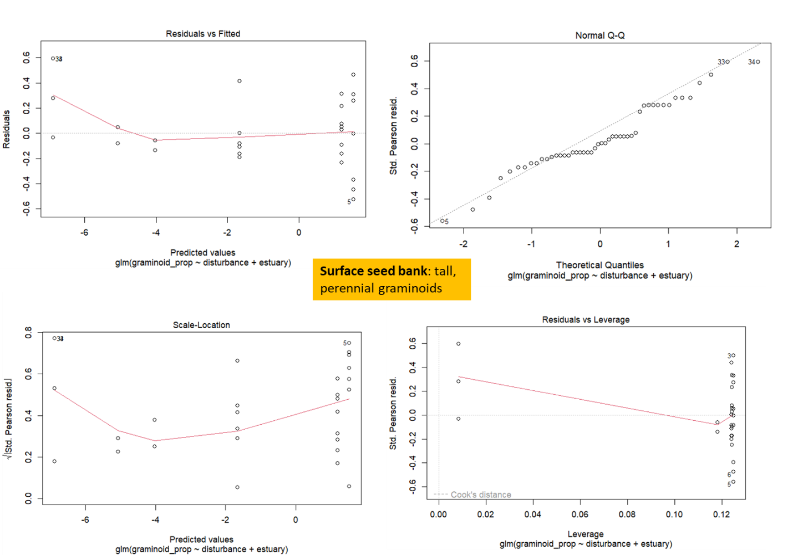

Figure 9. TEMP FIG - code output for in-text Results reporting glm trends in SURFACE SEED BANK. Outliers are samples dominated by forbs (especially Spergularia canadensis).